PERFORMANCE DRIVEN MARKETING (B9MK110)

Module/Subject Title: Performance-Driven Marketing.

Lecturer Name: Shaun Hayden.

Assignment Title: Assignment 2 – Marketing Strategy.

Student(s) Name & Number(s):

Chetan Padme (10393059)

Bhushan Chaudhari (10517074)

Pavan Pardeshi (10380700)

Kaushal Shivhare (10514804)

Word count: 3999

TABLE OF CONTENTS

TITLE : 4

INTRODUCTION 4

MARKETING PLAN 5

PART 1 6

EXECUTIVE SUMMARY 6

PROFILE OF TARGET CONSUMERS 6

UNIQUE SELLING PROPOSITION (USP) 6

DIFFERENTIATION 6

CUSTOMER RESPONSE & PERCEPTION 6

PART 2: CURRENT ANALYSIS ( INTERNAL LANDSCAPE) 7

Product 7

PRICING 8

PLACE 8

PROMOTION 8

PEOPLE 9

PROCESS 9

PHYSICAL EVIDENCE 9

PART 3: PESTLE & SWOT ANALYSIS 10

PESTEL ANALYSIS 10

ECONOMICAL 10

SOCIAL 11

LEGAL 12

TECHNOLOGY 12

SWOT ANALYSIS 13

PART 4 THE EXTERNAL LANDSCAPE(CURRENT SITUATION ANALYSIS) 13

MARKET OVERVIEW : 13

TARGET MARKET: 13

CUSTOMER ANALYSIS: 14

OPPORTUNITIES BECAUSE OF TECHNOLOGY CHANGE: 14

CULTURAL HABITS: 14

CONSUMER SENTIMENT. 14

COMPETITOR ANALYSIS: 14

PRICING AND POSITIONING STRATEGY OFFERS AND INCENTIVES: 16

CUSTOMER RETENTION 16

PART 5 MARKETING STRATEGIES: 17

KEYNOTE 17

THROUGH TRADITIONAL MARKETING 17

THROUGH DIGITAL MARKETING 17

THROUGH APPLESTORE AND AUTHORIZE PARTNERS 17

PROMOTIONAL OFFERS 18

NETWORKING EVENTS 18

CONTENT MARKETING 18

PART 6: CORPORATE SOCIAL RESPONSIBILITY 18

BIBLIOGRAPHY 19

APPENDIX: 21

Current analysis of Apple. 21

The comprehensive income statement of Apple 2017-18. 21

Rough work for SWOT Analysis. 22

**TABLE OF FIGURES**

Figure 1 Process flow chart. 9

Figure 2 Card Expenditure 10

Figure 3 Credit card expenditure in different categories. 11

Figure 4 OS Statistics market share in Ireland 11

Figure 5 contactless card transactions Value and volume, (bpfi, 2019). 13

Figure 6 SWOT Analysis: Apple Credit Card 13

**TABLE OF TABLES**

Table 1 Competitor analysis Part 1 16

Table 2 Competitor analysis Part 2 17

# TITLE :

**MARKETING STRATEGY FOR APPLE CARD (CREDIT CARD) IN THE NEW MARKET i.e. IRELAND.**

# INTRODUCTION

Apple is one of the big tech companies which have a global presence. They mainly operate in consumer electronics and related services. Laptops, desktops, phones, Smartwatches, speaker, etc these are their physical products whereas iTunes, apple music, podcasts, iCloud, OS platforms are the services they offer. They have developed an ecosystem and emphasis on innovation through R&D, because of which they are ahead of their competition for a long time. Now in 2019, Apple is coming up with Apple credit card Since they are new to the financial sector hence they have chosen to develop this product by segmenting the financial risk management, channel partner, and issuing bank among Goldman Sachs, Mastercard, and Green Dot Bank respectively. Considering how the product is developed with features, no fees structure, instant insurance, and cashback instead of reward points. On 25th March 2019 apple announced the apple card at Keynote event in the United States and consumers are waiting for it to arrive.

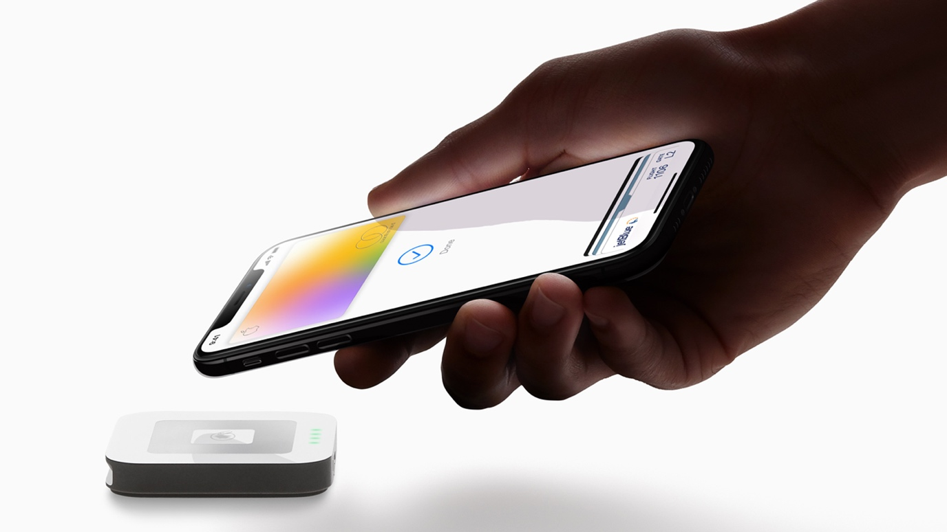

# MARKETING PLAN

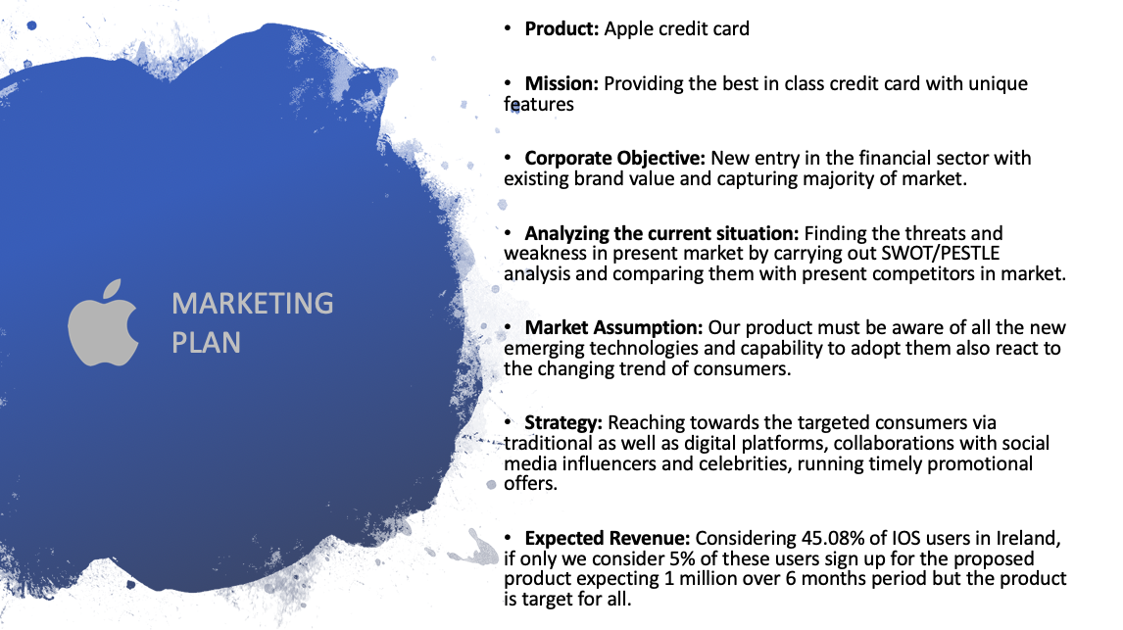

# PART 1

## EXECUTIVE SUMMARY

Launching apple card aims towards revolutionary impact in the financial sector & credit-based consumer market. With technology & unique features and apple, card wants to change the way people use credit cards as well as monitor their finances with ease. Our vision for apple card is to acquire as much as customer base which is divided into credit card users in the market by providing unique offers and special discounts for switching from other banks and new adaptors which was not previously using credit-based products.

## PROFILE OF TARGET CONSUMERS

According to the research from FICO, it is found that 83% of users of millennials age i.e. 25 to 34 use credit cards (Ashford, 2016). While 67% of the age group 18-24 use a credit card. The number of credit card users from the age group 35-49 and 50+ is 76% and 78% respectively. The central bank of Ireland segmented target market of credit card users in two main categories i.e. personal and business cards valuing 89% and 11% respectively. In May 2019 it is noticed that €770.41 million were spent from the personal credit card in Ireland (Central Bank of Ireland, 2019). From the reports, it is observed that Irish people tend more towards the credit-based system, which resulted increased the demand in the Irish market.

Ideally, the targeted consumer for our product must be millennials age but we can't ignore the age group of 35 and above. Income is the major deciding factor for our product when it comes to the target consumer. Those who have sufficient income source like working professionals, graduate students are considered as targeted consumers. Age, generations, income sources, employment status, and education are the factors considering which target consumers can find out. Our product aim is approaching consumers with the capability to repay and expand the market share.

## UNIQUE SELLING PROPOSITION (USP)

### DIFFERENTIATION

Cashback is a great starting point because it's so simple. Apple card gives daily cashback which is a very unique feature. Instated of giving points and rewards it gives direct cashback on every purchase or transaction. Like every consumer will earn 1% cashback on purchase made with the physical titanium credit card while 2% cashback on payments done using apple pay. Maximum of 3% cashback can be earned when the transaction is done at any apple store or for any apple service. These rewards alone qualify the card as one of the best cashback credit cards available today (McGrath, 2019).

### CUSTOMER RESPONSE & PERCEPTION

Consumers will get a physical titanium credit card as well as they can also make transactions using apple pay on their smartphone. They will gain direct cashback on every transaction which can be utilized to repay their balance also it can be utilized directly.

Consumers may consider this card as same as any other credit card but with added unique features and value-added benefits which will change their way of using a credit card on a different level.

# PART 2: CURRENT ANALYSIS ( INTERNAL LANDSCAPE)

Apple is an American multinational technology company and one of the big tech companies along with Google, Amazon, and Facebook whose headquarter is in Cupertino, California. Apple designs and develops one of the best computer software, consumer electronics, and online services. According to the annual report of 2018, total comprehensive income of Apple is $56,505(million). During the year 2016 and 2017, the comprehensive income was $46,666(million) and $47,567(million), which states the significant growth in the income of an organization. (Apple Inc, September 29, 2018)

The latest technology products, services, and brand loyalty make Apple the world's most valuable brand. In the USA, Apple recently launched the Apple Credit Card which will be in the market in the first week of August. However, this Apple card will be then launched in the Irish market in coming fall.

## Product

Apple has redefined the credit card concept for the consumers of credit base system. This apple card is then backed up by the apple pay which was introduced previously. The main factors which make apple card stand out are the simplicity of card, transparency and their high privacy policies. Moreover, Apple card provides the variable & flexible interest rates for users which differentiate apple card from their competitor who operates in the concerned area. Additionally, instead of points and gimmicks, daily cashback (real cash) on every purchase which goes into the Apple Cash Card, is also an interesting feature of Apple card.

People can track their every transaction on the mobile application and connect to customer support if needed via inbuilt messenger feature in the application. Apple focused more on the privacy and security of the users by using advanced technologies such as Face ID, Touch ID, unique transaction code and last but not least, there is no card number and any details on the card itself other than the name of the cardholder. As every credit card needs an issuing bank, Apple Inc tied up with the Goldman Sachs bank and apple card is the first consumer card they’ve issued. However, The Apple Cash card is issued by Green Dot Bank, Member FDIC. (Apple, 2019)

## PRICING

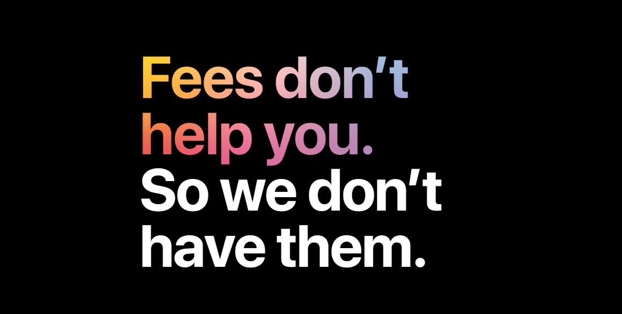  
One can get this card by signing in via apple ID. Apple states that it makes easier to take down the balances rather than getting harder which is possible because of the NO FEES criteria. There are no annual, advance cash, over and low limit fees, as well as no late fees, are applicable. Low and flexible interest rates are the concept in which, at the time of payment, Apple card provides an estimated amount of interest which is applicable based on the amount chosen. However, the APR (Annual Percent Rate of interest) is variable. This will help cardholders to decide how much money to pay down. (Apple INC, 2019)

## PLACE

Place element for this product in the marketing 7 P’s integrates the following sales channels:

* **Apple authorized retailers:** Apple operates stores in 45 countries worldwide. In apple authorized retailer, consumers can use products and get friendly assistance from customer service representatives. (Apple INC, 2019)
* **Online Stores:** Customers can apply online to get updates regarding the apple card from its official website. (Apple INC, 2019)
* **Authorized resellers:** Apple partners with many retailers to distribute services like iConnect, CompuB, Nyassa, B2X, Unicorn, etc**.**

## PROMOTION

The focus of the promotion is how Apple products are different than the competitors. As Apple does promote their product via commercial ads when a product is first launched. However, print advertising will run throughout the product’s life. Same will be the case of Apple credit card. Promotional ads will be simple and to the point, focusing on the features of the card.

Another component of Apple’s promotion is the yearly keynote speeches. These events are the type of its overall promotion of products but now it has become a part of brand and image. Hence, Apple will also promote credit card through the events to keep consumers interested.

## PEOPLE

It is important to have dedicated people in a team to promote Apple Card, for which they should have proper product knowledge. In addition to the in-house team, very strict guidelines will be established for employees as well as regional marketing agencies and influencers which will be partnering with us for the promotion. To keep the flow of information close to what it is.

## PROCESS

To promote the apple card in the Irish market we used the strategy and process which has been followed for the greater success of the project. Weekly check for the regular advertisements and promotional reports will be monitored.

Figure 1 Process flow chart.

## PHYSICAL EVIDENCE

Our stores (online and offline) are creatively designed and spacious place where consumers can have a look at our new products and get friendly assistance from customer service representatives. Our promotional videos, advertisements, news, billboards, digital advertises, physical credit cards and cash cards, Apple online store and our mobile applications for iOS as well as Android are the physical evidence of product marketing strategy.

# PART 3: PESTLE & SWOT ANALYSIS

## PESTEL ANALYSIS

Below out of the six pestle factors we have discussed few which seem to be important from the product point of view which gives us brief inputs on how the challenges can affect companies goals and motives in a particular market (Ireland).

ECONOMICAL

According to statistics shared by Central bank of Ireland, 2019 card transactions have shown an increase of 9% (Debit and Credit Both) (Central Bank of Ireland, 2019). Moreover, the number of an individual point of sale for a credit card has been recorded 34 million with an average expend of 80.12 euro per transaction. Overall the introduction of apple credit card in the Irish market seems to be a good move from an economic point of view.

Figure 2 Card Expenditure

The report further gives a detail view of the usage of credit cards by Irish people in the different sectors, which is broadly divided into 3 categories Social, Retail and Services. It was observed that credit card expenditure witnessed a hike in the area to retail by 10% and by 11% in the other two areas (Services & Social). Hence shows the interest of Irish people towards the usage of a credit card. Moreover, it was noted that 50% of credit card spending is done on e-commerce.

Figure 3 Credit card expenditure in different categories.

SOCIAL

The social and cultural attitude of the Irish population towards credit card is positive as discussed in the above section people are showing interest in credit cards. According to the survey by Statcounter, 45.08% of the people are using an IOS device which further indicates the stronghold of apple in the Irish market and hence this increases the probability of the usage of Apple’s credit card (Statcounter, 2019). Apple has a trustworthy image and because of this it has a loyal customer base all over the world, Ireland is no different.

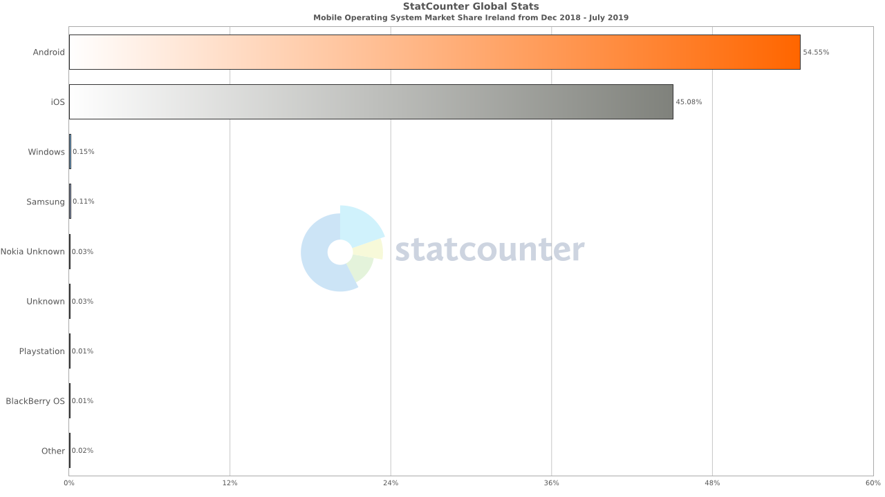

Figure 4 OS Statistics market share in Ireland

According to the report by Weston,most of the Irish people who use credit cards are not aware of the interest rate that is being charged to them at the end of the month or by the year-end (Charlie Weston, 2019). Moreover, the report suggests that people are poorly aware of how interest works. With apple's new credit card these users can keep themselves well informed as the card comes within graded feature by which people can monitor their spending and the interest that they are being charged upon.

LEGAL

Report by Brewster, for Forbes, stated that Apple has lost millions of dollars to fraudsters/hackers who were able to crack down a gap between apple pay and banking system and was successful in taking away millions from apple (Brewster, 2019).

Another case was reported where a group of fraudsters/hackers uploaded stolen JP Morgan credit cards to apple pay and other digital wallets and looted around 600,000 Dollars. Apple has learned a lot from these mistakes and has done the required changes before launching its credit card, the reason this time there is no numbers on the credit card to make it more secure.

Apple as a company was charged around 14 billion Euros to Ireland for the disputed back taxes in May 2018 (Toplensky, 2018). This is before the “*Digital Turnover Tax”* bill was passed by the European Union. Now that the bill has been passed the European Union companies are trying to take an extra bit of tax from the tech multinational giants. Apple new credit card should amend the all such policy along with the new GDPR rules which the EU seems to be pretty strict on.

TECHNOLOGY

Being a part of European union Ireland is updated with technology also in past 2 decades a heavy change in technology is seen in Ireland top pharmaceutical, medical devices and IT companies have their presence in Ireland and are invested in research and development. Though banking sector in Ireland is a small yet significant improvement in practices is seen in Ireland which is result increase big data & fintech innovation, for example, telematics-based innovation in the car insurance market (Central Bank of Ireland, 2019). In context to the banking sector and personal finances, Ireland has shown €1369 million i.e., 59.2% of the total transaction are made contactless in Quarter 4, 2018 which is almost 3 times that of quarter 4, 2016. This is because of increased innovation and adoption of banking practices (bpfi, 2019).

Figure 5 contactless card transactions Value and volume, (bpfi, 2019).

## SWOT ANALYSIS

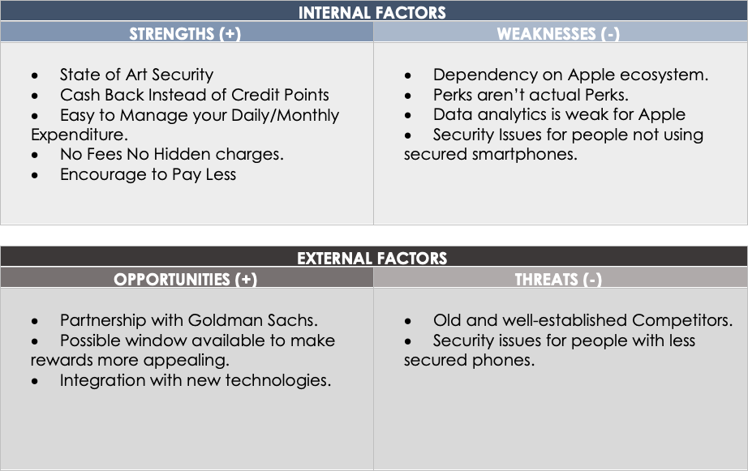

Figure 6 SWOT Analysis: Apple Credit Card

# PART 4 THE EXTERNAL LANDSCAPE(CURRENT SITUATION ANALYSIS)

## MARKET OVERVIEW :

In the Irish market, debit card expenditure is 5 times that of credit card expenditure (Peter Hamilton, 2019). Credit and debit card statistical report published by (Central Bank of Ireland, 2019) states that in the first quarter of 2019, debit card transaction was 5.3 times the value of credit card expenditure. Year on year increase of 19% is seen in debit cards expenditure whereas 9% in case of credit cards. Increased expenditure is evenly distributed along with retail, service and social sectors. This shows though debit and credit cards are two entirely different products yet the increase in expenditure is a result of increased consumer spending and uneven disposable income

## TARGET MARKET:

The target market for Credit cards are mainly divided into two main categories personal cards and business cards the distribution of that is approximately 89% and 11% as per the reports of Central bank of Ireland. When introspected it is seen that the business cards are having a comparatively large number of transactions as compared to that of personal cards (Central Bank of Ireland, 2019).

Whereas the distribution of personal credit cards is broken down among the individuals, it is seen that there is no gender bias is seen and the people below the age of 21 years i.e., post-millennials have negligible possession of credit cards. Also, the same observed in the case of people above the age of 70 years i.e., Silent Generation. This narrows down to the people in the age bracket of 21 to 70 years this is the dominating population which holds credit cards personal and or business.

## CUSTOMER ANALYSIS:

This age bracket can be further broken down into baby boomers (54-72 years old)

and Millennials (22-37 years old) & Generation X (38-53 years old). The exact distribution is difficult to interpret but the factor influencing the choices are the disposable income, increased spending in sectors and particularly in the e-commerce environment the reason to particularly identify this is the various offers and schemes available in the e-commerce business for credit card holders, and lifestyle choices as well.

## OPPORTUNITIES BECAUSE OF TECHNOLOGY CHANGE:

The financial corporation has greatly benefited from the application of RFID and NFC technologies which they have incorporated in their payment methodologies to make their credit or debit card contactless which was a huge change. Whereas the application interface which FCs have developed to give a consumer a walkthrough in their finances have also been an addition. Nowadays most of the financials corporations and banks provide these services as a default experience.

## CULTURAL HABITS:

Adoption of this technological innovation was initially slow and as the time progressed it has shown growth and now in 2019 it is not wrong to say that the masses have inculcated these habits in their lifestyle and demanding a more fluid experience.

## CONSUMER SENTIMENT.

Since the beginning of 2019, the consumer sentiment index has started to decline and the reason behind that is deterioration in the view of the current condition. This kind of decline is seen last in October 2014. Whereas the consumer expectation index has also seen a decline. An only tolerable revision in expectation is seen in the case of Household’s outlook on the general economy and unemployment. View of personal finances of households in terms of current circumstances and forward-looking views are worsened in recent times the reason behind that is slightly increased current condition whereas the worsening of expectation overall. Hence the overall confidence is relatively positive because the households are expecting a strong change over the coming year. This uncertainty in expectation is because of Brexit negotiations & implication (KBC Bank Ireland, 2019)

## COMPETITOR ANALYSIS:

Banking Sector in Ireland is quite small, 5 major banks are currently serving the population. All the banks have their credit card services available to the customer most of them are customer-specific. List of the players and their customer-specific cards are mentioned below.

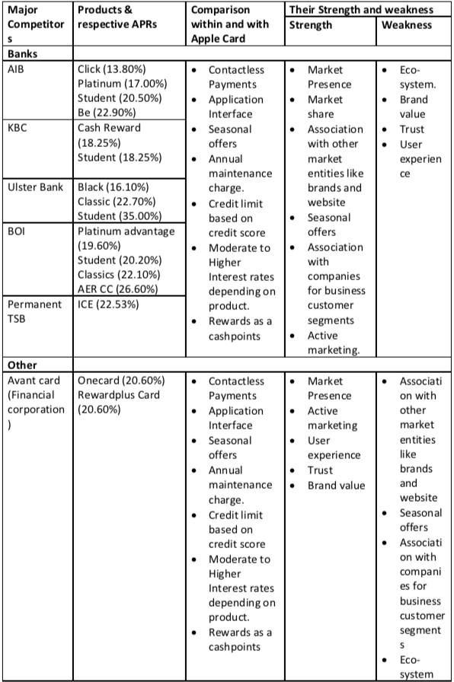

Table 1 Competitor analysis Part 1

## PRICING AND POSITIONING STRATEGY OFFERS AND INCENTIVES:

* Apple has kept a variable APRs range of 13.24% to 24.24% and the rate will be given based on customer's creditworthiness backed by his credit score.
* Whereas the consumer can improve his or her APR by maintaining their payments timely. Also if they miss a payment no late fees will be charged but a higher interest penalty will be charged which a customer can improve over time.
* Also, the consumer's posted account balance will help estimate the Interest. Hence to advisable not include pending transactions or purchases before the end of the billing period (Apple Inc., 2019).

Other than the competitors mentioned above, there are few more which don't offer credit but their services are an exact match to what apple card is coming with. Analysis of those is mentioned below.

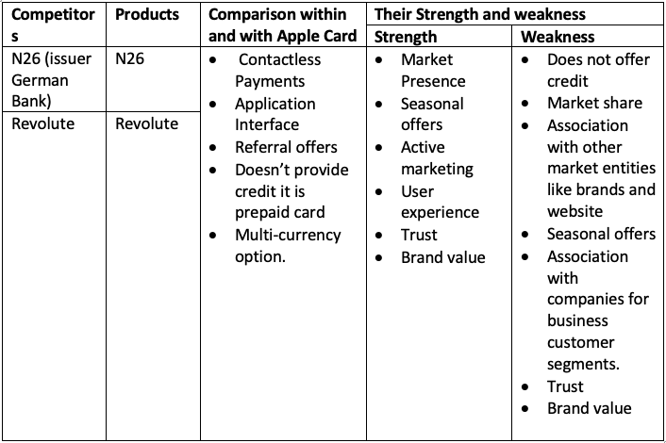

Table 2 Competitor analysis Part 2

## CUSTOMER RETENTION

A survey carried out by (Harward Business Review Analytical Service, 2018) concludes that the most effective brands possess these three capabilities unified customer data platforms, proactive & contextual interactions. Apple has demonstrated these qualities countless time and has maintained robust customer experience. With the help of apple card application & apple pay in addition to physical apple card, Apple is planning to reinvent how customers see credit card and enrich user experience.

Customer retention is always been a vital part of any business and it is driven by retention strategies which the company applies. Being apple what it is, they have a fully optimize stack of technology i.e., from hardware & storage to software & application. It helps them to handle a variety of analytics and come down the desired outcome which helps them develop retention strategies. Since Apple card is a new product, which is not yet launched. it is difficult to develop a retention strategy with no analytics of performance. In this case, a base strategy is developed for a customer who opts to move out after initial adoption until a robust data arrives to target specific issues.

# PART 5 MARKETING STRATEGIES:

The whole process of marketing and promotion is done in various parts & mentioned below.

## KEYNOTE

Though this is not a first time, Apple is coming up with a new product but to engage the customer and to demonstrate the product. Apple has always kept one simple strategy to educate the consumer by holding a keynote. In the case of Ireland, it will be a beneficiary step since the consumers are not aware of what APRs they are being charged to.

## THROUGH TRADITIONAL MARKETING

Ireland has approximately 60 newspaper and 150 periodical and trade magazine hence Advertisement through newspapers, billboards, brochures, magazines will be rolled out before and after the keynote. To keep consumers notified about the keynote and after to maintain the impact. A regulatory check will be planned whether the things are going according to plan & legally considering advertisings standards authority of Ireland’s requirement. During SWOT analysis a cultural factor observed is people are prone to accept a product if it is marketed out in public event hence, popup events will be organized in the populated areas during weekends with the help of regional event management agencies.

## THROUGH DIGITAL MARKETING

Digital advertisement will be rolled out for digital billboards. Also, advertisements through streaming platforms like YouTube, Netflix, Etc. will be rolled out. In addition to this Marketing through social media will be done via apple’s Facebook, Instagram, Google+ handle & in collaboration with internet celebrities, influencers as well.

## THROUGH APPLESTORE AND AUTHORIZE PARTNERS

After the Launch of the product the apple store and apple authorized partners like Iconnect and CompuB, etc will be a key areas of marketing where the customers can get personal experience and clear out there queries to enhance the process, separate staff or selected staff will be trained for the product features and how to market it out.

## PROMOTIONAL OFFERS

1. Promotional offers for a referral will be given to consumers in terms of 5% cashback on their next purchases.
2. Promotional offer for Consumers coming from competitor credit cards will be given which will be their balance will be kept on 0% APR for the first year.
3. Timely Balance transfer promotions will be given based on seasonal transfers.

* During January, 3% Cashbacks on the transfer of holiday balance.
* During April, 0% Interest on credit spending on taxes.
* During September, 2% cashback will be given on transfer of tuition fees.

## NETWORKING EVENTS

Once the product is launched Apple can utilize the opportunity of promoting it via networking events like Tech fairs which are happening across Ireland in regular intervals and can easily attract public and masses to get an overview of the product. Usually, such events have our target audience present, and it can be beneficial for the product to gain some initial market.

Another way to market is through Music Events and National Sports Events where with the help of electronic display banner we can market the product. Irish people craze towards football and music is well known and people love to visit such events always, we can leverage this chance to make our product noticed by thousands of people.

## CONTENT MARKETING

We as a team believe the utilization of digital marketing should be optimum and by putting blogs and videos about our product which briefly explains the specifications and features of the product. This content can be put up in public platform and electronic media like YouTube and e-papers. Moreover, we can invite experts from the field of banking to talk about product pros and cons.

# PART 6: CORPORATE SOCIAL RESPONSIBILITY

**APPLE CSR PROGRESS**

Apple’s Corporate Social Responsibility program is headed by *Lisa Jackson* who holds the chair of *Vice President of Environment Policy and Social Initiatives* and reports directly to Tim Cook.

* Apple is very transparent considering the environmental impact they have chosen to go ahead, with practices like using eco-friendly materials, less packaging which in the end helps them reduce carbon footprint.
* With this product, they want to educate the consumer on how they can manage their finances better way.
* With apple card, they have devised an intuitive interface which helps them inculcate consumer to opt for no receipts which will again reduce the population.
* Apart from the product, Like the clean water program in 2013, apple will engage in developing innovating practices for waste management authorities in Ireland to reduce pollution.

# BIBLIOGRAPHY

Apple Inc, September 29, 2018. *ANNUAL REPORT PURSUANT TO SECTION 13 OR 15(d) OF THE SECURITIES EXCHANGE ACT OF 1934,* s.l.: Apple Inc.

KBC Bank Ireland, 2019. *https://www.esri.ie.* [Online]   
Available at: https://www.esri.ie/system/files/publications/CSI2019APR.pdf  
[Accessed 27 July 2019].

Harward Business Review Analytical Service, 2018. *https://www.sas.com.* [Online]   
Available at: https://www.sas.com/content/dam/SAS/en_us/doc/whitepaper2/real-time-analytics-109676.pdf  
[Accessed 27 July 2019].

Ashford, K., 2016. *Forbes.* [Online]   
Available at: https://www.forbes.com/sites/kateashford/2016/06/30/millennials-credit-card/#25dffc1a6ee3  
[Accessed 2 July 2019].

Central Bank of ireland, 2019. *https://www.centralbank.ie.* [Online]   
Available at: https://www.centralbank.ie/statistics/data-and-analysis/credit-and-banking-statistics/credit-and-debit-card-statistics  
[Accessed 29 July 2019].

Peter Hamilton, 2019. *Irish times.* [Online]   
Available at: https://www.irishtimes.com/business/economy/irish-consumers-increasingly-using-credit-and-debit-cards-1.3900575  
[Accessed 30 July 2019].

Central Bank of Ireland, 2019. *Central Bank of Ireland.* [Online]   
Available at: https://www.centralbank.ie/statistics/data-and-analysis/credit-and-banking-statistics/credit-and-debit-card-statistics  
[Accessed 30 July 2019].

Apple Inc., 2019. *Apple.* [Online]   
Available at: https://www.apple.com/apple-card/  
[Accessed 30 July 2019].

Apple, 2019. *Apple Inc.* [Online]   
Available at: https://www.apple.com/ie/newsroom/2019/06/highlights-from-wwdc-2019/  
[Accessed 20 July 2019].

Apple , 2019. *www.apple.ie.* [Online]   
Available at: https://www.apple.com/apple -card/  
[Accessed 19 July 2019].

Apple INC, 2019. *www.apple.ie.* [Online]   
Available at: https://www.apple.com/apple-card/how-it-works/   
[Accessed 20 July 2019].

Apple INC, 2019. *www.apple.ie.* [Online]   
Available at: https://www.apple.com/retail/storelist/   
[Accessed 22 July 2019].

Apple INC, 2019. *www.apple.ie.* [Online]   
Available at: https://www.apple.com/apple-card/#footnote-7  
[Accessed 22 July 2019].

statcounter, 2019. *statcounter.* [Online]   
Available at: http://gs.statcounter.com/os-market-share/mobile/ireland/#monthly-201812-201907-bar  
[Accessed 29 July 2019].

Charlie Weston, 2019. *Indipendent.ie.* [Online]   
Available at: https://www.independent.ie/business/personal-finance/majority-of-people-dont-know-what-interest-rate-is-on-their-credit-cards-37883899.html  
[Accessed 15 July 2019].

Brewster, T., 2019. *Forbes.com.* [Online]   
Available at: https://www.forbes.com/sites/thomasbrewster/2019/03/27/millions-are-being-lost-to-apple-pay-fraudwill-apple-card-come-to-the-rescue/#2e674988622f  
[Accessed 15 July 2019].

Toplensky, R., 2018. *Financial Times.* [Online]   
Available at: https://www.ft.com/content/bff4b32c-bb4d-11e8-8274-55b72926558f  
[Accessed 20 july 2019].

Apple INC, 2019. *apple.ie.* [Online]   
Available at: https://www.apple.com/apple-card/privacy-security/  
[Accessed 15 July 2019].

McGrath, L., 2019. *Bloomberg.* [Online]   
Available at: https://www.bloomberg.com/news/articles/2019-07-23/cash-is-king-when-it-comes-to-credit-card-rewards  
[Accessed 28 July 2019].

Central Bank of Ireland, 2019. *Central Bank of Ireland.* [Online]   
Available at: https://centralbank.ie/consumer-hub/explainers/what-is-fintech-and-how-is-it-changing-financial-products  
[Accessed 30 July 2019].

bpfi, 2019. *Banking and payments federation Ireland.* [Online]   
Available at: https://www.bpfi.ie/wp-content/uploads/2019/05/BPFI-Payments-Monitor-H2-2018-FINAL-for-website.pdf  
[Accessed 30 July 2019].

# APPENDIX:

### Current analysis of Apple.

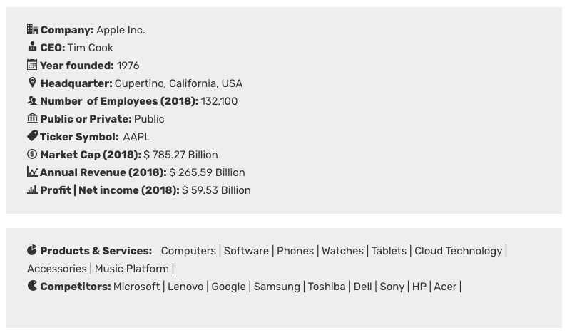

### The comprehensive income statement of Apple 2017-18.

### Rough work for SWOT Analysis.

